Bug Reports

#### Bug 1

| **Results can be outside of start/end date range when using ISO 8601 format** | | |
| --- | --- | --- |
| **Pri:**  tbd | **Sev:** tbd |  |
| **Environment:** Chrome v120, Windows11 | | |

Results can be outside of the entered start/end date range for ISO 8601 format.

**Repro steps:**

1. On a computer set to a different time zone than UTC+00:00, open <https://codebeautify.org/generate-random-date> in Chrome.
2. In the ‘Start date’ textbox, enter the first minute of the last day of a year (e.g. 1999-12-31 00:00:01).
3. In the ‘End date’ textbox, enter the last minute of the same date (e.g. 1999-12-31 23:59:59).
4. Set ‘Date Output Format’ to ISO 8601.
5. Set ‘How many dates to generate’ to 100
6. Click Generate Random Date a few times while observing the results.

**Expected:**

Random dates would be within the range provided in the Start date and End date fields

**Observed:**

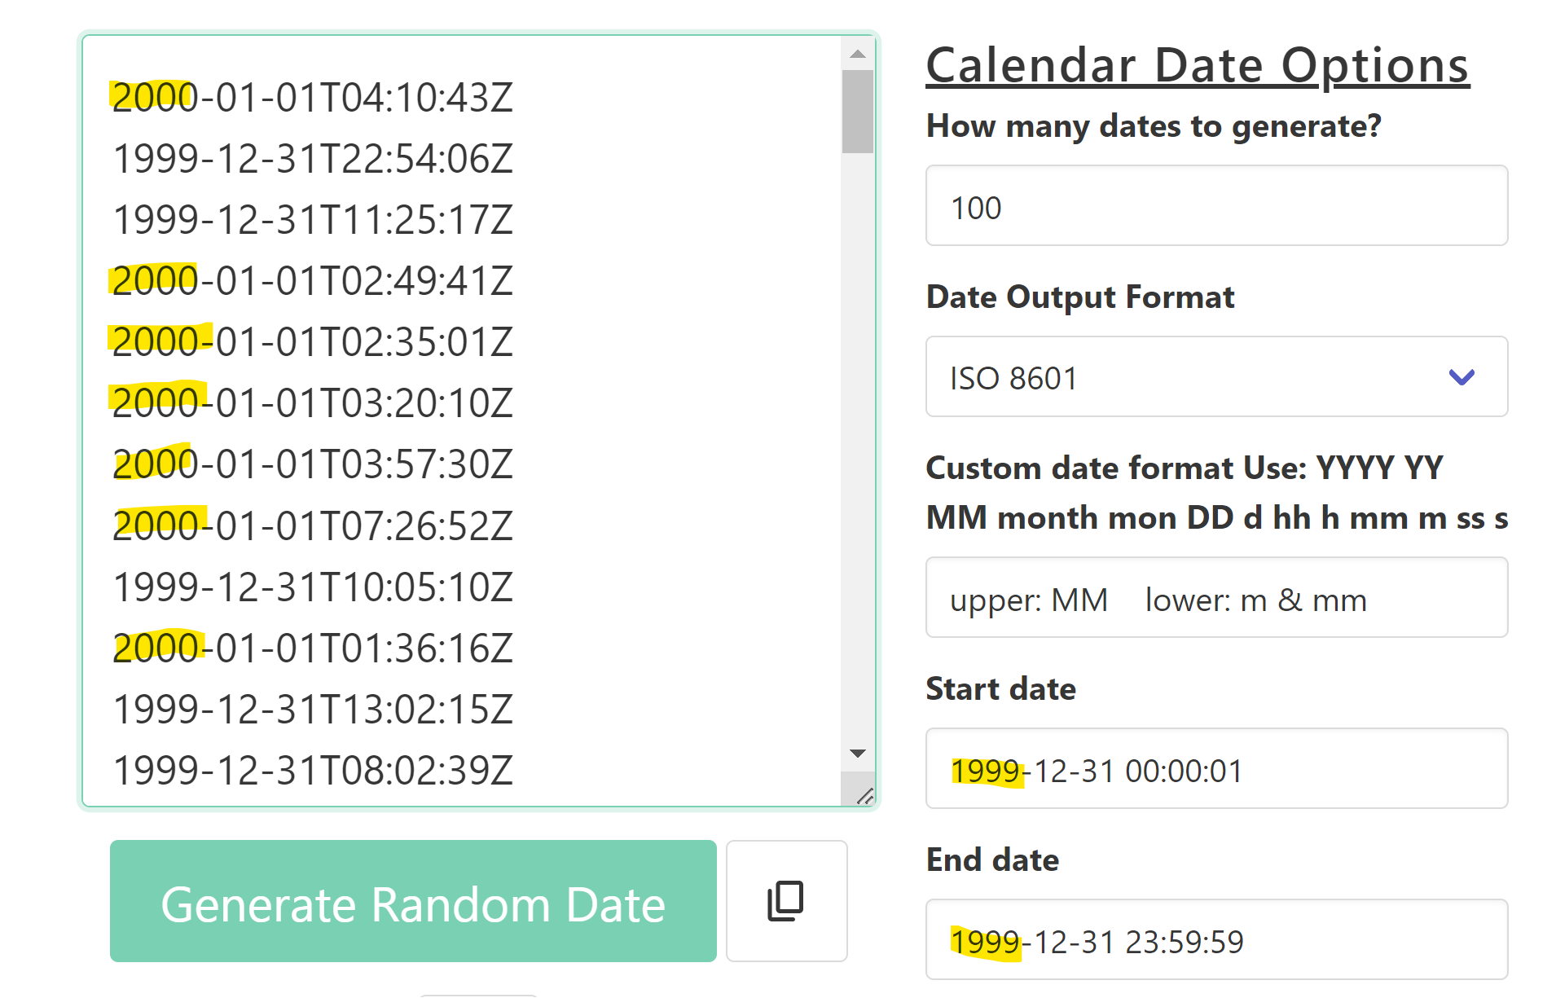

Once the ‘Date Output Format’ is set to ISO 8601, some results were beyond the range provided; possibly dependent on the UTC offset for your Computer. My time zone is UTC-08:00 and my results were between 1999-12-31T08:00:01Z and 2000-01-01T07:59:59.

#### Bug 2

| **Year Date Month format outputs incorrect format (year month date)** | | |
| --- | --- | --- |
| **Pri:**  tbd | **Sev:** tbd |  |
| **Environment:** Chrome v120, Windows11 | | |

**Repro steps:**

1. Open <https://codebeautify.org/generate-random-date> in Chrome.
2. In the ‘Date Output Format’ field, select ‘*Year Month Date hh:mm:ss*’.
3. Verify the results are in the specified format
4. In the ‘Date Output Format’ field, select ‘*Year Date Month hh:mm:ss*’.
5. Verify the results are in the specified format

**Expected:**

Results would match the output format selected in ‘Date Output Format’.

**Observed:**

‘*Year Date Month hh:mm:ss*’ results were in Year Month Date format.

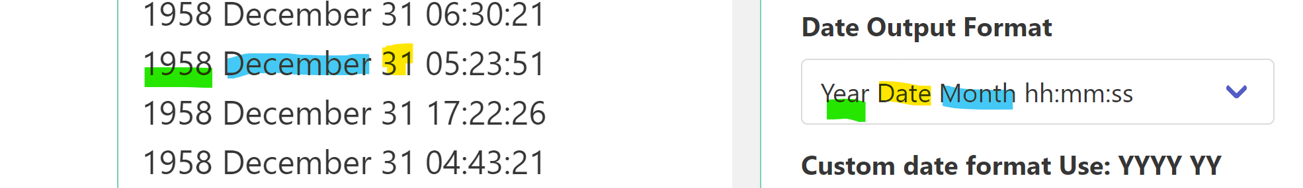

#### Bug 3

| **Custom Date Format’s ‘month’ results display values instead of the letters for h,y,m** | | |
| --- | --- | --- |
| **Pri:**  tbd | **Sev:** tbd |  |
| **Environment:** Chrome v120, Windows11 | | |

If the ‘month’ result string includes one of the custom strings, that letter will be replaced with numbers (e.g. August displays as Augu8t)

**Repro steps:**

1. Open <https://codebeautify.org/generate-random-date> in Chrome.
2. In the ‘Date Output Format’ field, select ‘Custom date format’.
3. In the ‘Custom date format Use:’ field, enter ‘DD month YYYY’
4. In the Count/’How many dates to generate?’ field, select 100.

**Expected:**

Results would properly display DD month YYYY format (e.g. 26 August 1998)

**Observed:**

The results don’t properly display the names of the months if the months include the letters used within the custom date format (e.g. h,y,m).

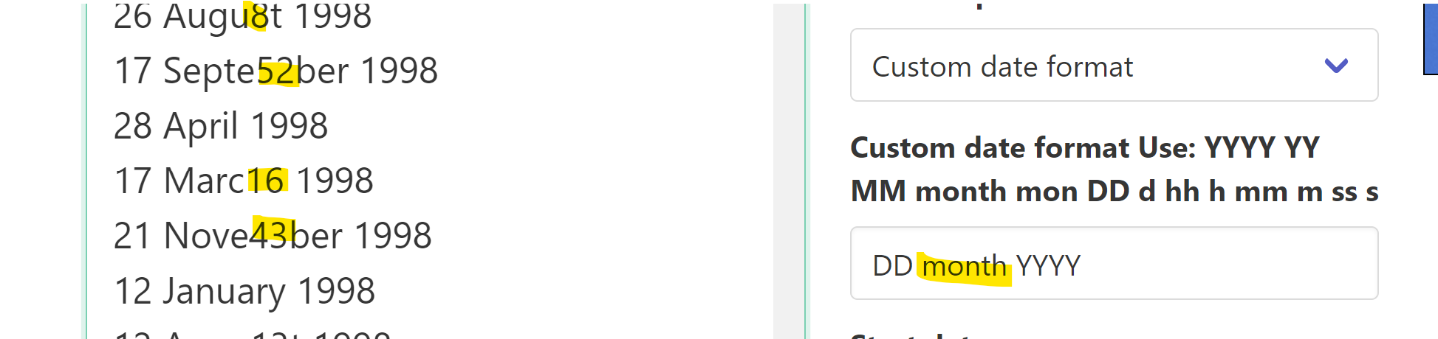

#### Bug 4

| **Custom Date Format’s lowercase ‘m’ is incorrectly displaying in results** | | |
| --- | --- | --- |
| **Pri:**  tbd | **Sev:** tbd |  |
| **Environment:** Chrome v120, Windows11 | | |

The lowercase ‘m’

1. Does not display the correct value for ‘m’ or ‘mm’.

**Repro steps:**

1. Open <https://codebeautify.org/generate-random-date> in Chrome.
2. Ensure the ‘Start date’ and ‘End date’ fields will return results for all twelve months.
3. In the ‘Date Output Format’ field, select ‘Custom date format’.
4. In the ‘Custom date format Use:’ field, enter ‘mon: upper: MM lower: m & mm’
5. In the Count/’How many dates to generate?’ field, select 100.

**Expected:**

Results will correctly show the correct number value for each month when using MM, mm and m.

**Observed:**

When ‘m’ or ‘mm’ is used, the value displayed usually isn’t the correct value for the month.

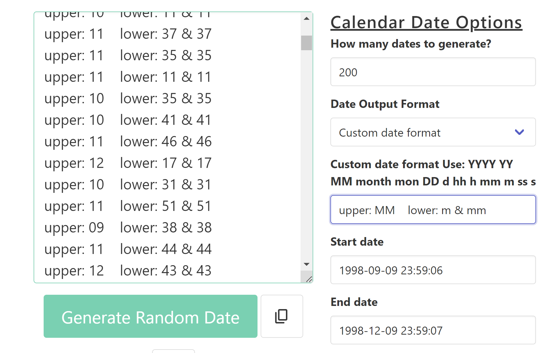

#### Bug 5

| **Count field is not restrained to acceptable values** | | |
| --- | --- | --- |
| **Pri:**  tbd | **Sev:** tbd |  |
| **Environment:** Chrome v120, Windows11 | | |

The Count / ‘How many dates to generate’ field is not restrained to values greater than 0 and will allow the user to enter a number that will result in an ‘Out of Memory’ value.

**Repro steps:**

1. In ‘How many dates to generate’, use the selector to select numbers below 1
2. In the same field, type in/paste a large number (e.g. 100000).

**Expected:**

* Only valid entries could be selected with the selector. Invalid entries would display helper text with the field’s boundaries/acceptable value.
* The user would not be able to enter a number that results in the tab ‘crashing’ with an ‘Out of Memory’ error.

**Observed:**

* User can select numbers below 1.
* User can enter very large numbers that will result in the browser hanging and ultimately displaying an ‘Out of Memory’ error.

# Additional issues:

1. Start date can be before End Date; results will not include either the start or end datetimes. If the dates are the same, start time is 23:59:59 end time is 23:59:57, the only results will be for 23:59:58.
2. App’s name should be standardized to a single string, as it currently refers to itself as ‘Random Date Generator’, ‘Date Generator’ and ‘Random Date Generator Online’.
3. Some of the strings should be edited to improve clarity and fix grammatical errors.